High-level summary: 3 Steps to Initiate a Multistate Project
- Find a Multistate project to participate in and submit a participation form (Appendix E) in NIMSS.
- Draft a project for your Department Chair and the AgDean’s feedback and approval
- Initiate a project in NRS

1- Instructions for Submitting an Appendix E in NIMSS Re: Participation in a Multistate Project
- First, you must be registered in the NIMSS system.
Register for an account with the National Information Management & Support System (NIMSS) by clicking the “New User” link in the upper right corner of https://nimss.org/

- Next, you must choose a Multistate project in which to participate. If you do not have a particular project in mind, you can search in NIMSS for all currently active projects.
After logging into NIMSS, in the menu bar, select “Projects” > “View All Projects”. You will see a master list of every project, from which you can search for one of interest to you. From the master list, if you click on the project number, it will take you to the details of the project for more information; if you click on the back arrow in the upper left corner of your screen, it will take you back to the master list where you can scroll through the projects. You can also search for a specific project. In the menu bar, select “Projects” > “View Projects”; the “Search for Project” screen will appear, then enter the project number, then click search, and it will take you to the details of the project. Click on the arrow in the upper left corner of your screen to return to the search screen.

Additional Information:
NIMSS categorizes projects by region, and there are a total of 5 region categories as follows:
- N – National
- NC – North Central
- NE – Northeast
- S – South
- W – West

The first few characters of a project number signify the originating region of the project. For example, project S1060 is a project in the South region and project W3185 is in the West region. Anyone can participate in any project in any region. Exception: Project NC100 – Regional Research Coordination, North Central Region, NE059 – Multistate Research Coordination Northeastern Region, S065 – Multistate Research Coordination, Southern Region, and W106 – Multistate Research Coordination, Western Region are all considered central ANR projects and only the Station Directors in each respective region should be listed as a participant for these projects.

There are also different types of Multistate projects, identified in the first few characters of the project number (see acronyms from the West region below):
- W – Multistate Research Project
- WERA – Hatch Multistate Education/Extension and Research Activity
- WCC – Multistate Research Coordinating Committee
- WDC – Development Committee
(Examples: WERA060 and WCC1008.) Each project type has its own focus and duration, and details for each specific project for each region are available within NIMSS as mentioned above.

- Complete the Appendix E form online once you’ve identified a project you would like to join.

Participation Form/Appendix E Information
This function is used to enter new participants into projects. Click “Participants” on the left, “Draft/Edit Participant” > “Draft New” screen. The following will appear:

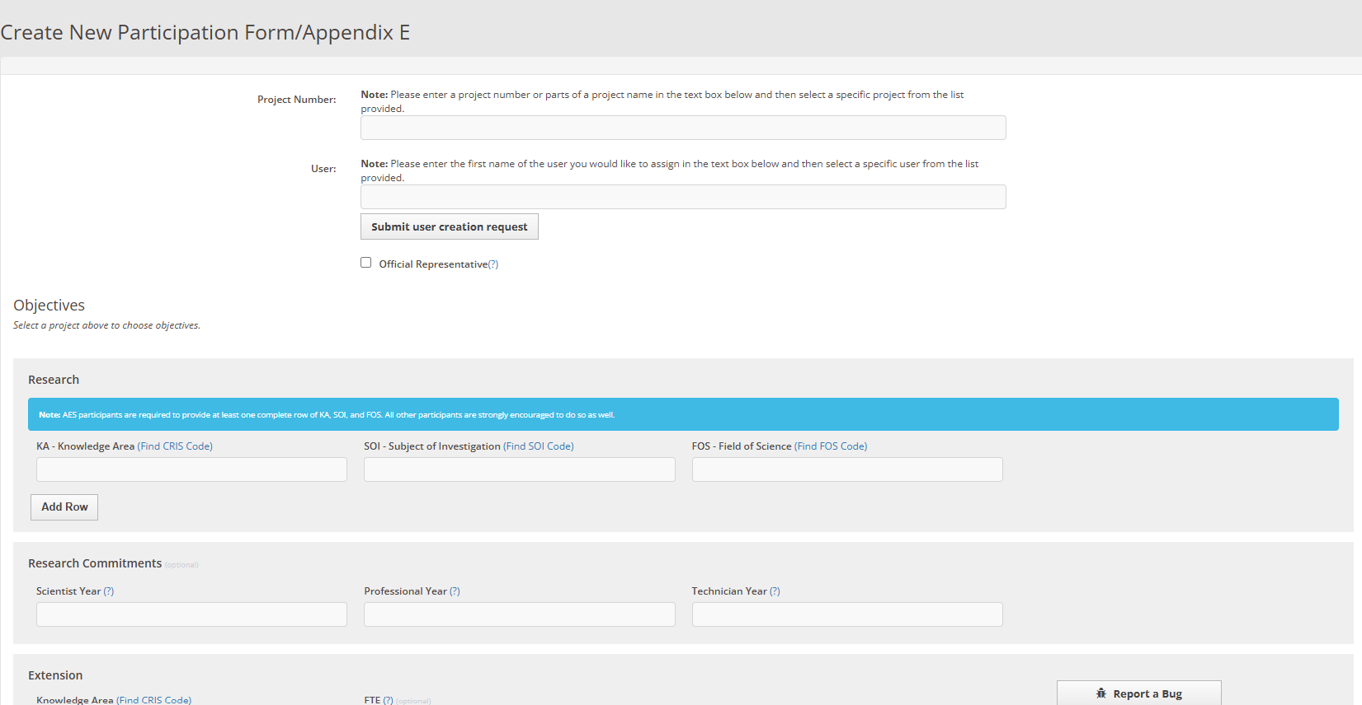
Enter new participant information:
- Project Number: Select the regional association to which the project belongs, then select the project number. The title of the project should automatically appear.
- Name: Use the drop-down menu to choose your name. You MUST be registered in NIMSS to appear in the dropdown
- Official Representative: Determine if the new participant will be the official voting representative to the project. Only one voting representative is allowed per institution per project (although, you may list several people as members of a project). If the person is the official voting rep to the project, place a check mark in the box next to, “Is this Person the official station representative to this project?” After placing a checkmark in the box in the Appendix E for that project, the participant’s name will appear with a * next to it, indicating that that person is in fact the official voting representative.
- Research: this is the section where participants enter their CRIS codes. For more information on CRIS codes, click the link above each research box (Knowledge Area (KA), Subject of Investigation (SOI), and Field of Science (FOS)). Make sure that the values given to KA, SOI, and FOS are valid numbers. Do not leave these fields blank if you enter SY, PY, TY information. If you need to add more combinations of KA-SOI-FOS information, click the button “Add More Rows.” The RPA-SOI-FOS and combination thereof are used frequently in searches and are found very useful when locating scientists conducting research in similar areas or Fields of Science.
- Research Commitments: the default value is zero for any of the categories (Scientific Years (SY); Project Years (PY); and Technical Years (TY)). Make sure that for the SY, PY, and TY values, you provide valid numbers. Also, note that SY should not be less than 0.1.
- Extension: If no FTE is provided, the fields default to zero. Participants can be involved in more than one extension program. You may click the button “Add More KAs”.

Click the submit button when finished entering the participant information. This will send an email to the participants, CRIS, and CSREES, as well as a confirmation email to the submitter. You may also choose NOT to send email notifications (this should be used ONLY in the case that a minor edit has been made) by selecting the “NO” radial button next to “Send email to participants”.

Once the “Appendix E” in NIMSS is approved, complete step 2, drafting your Multistate project.

If there are any questions regarding participation input, contact the regional system administrator. You can find their contact information by navigating to Directory > Regional Offices > Regional System Administrator
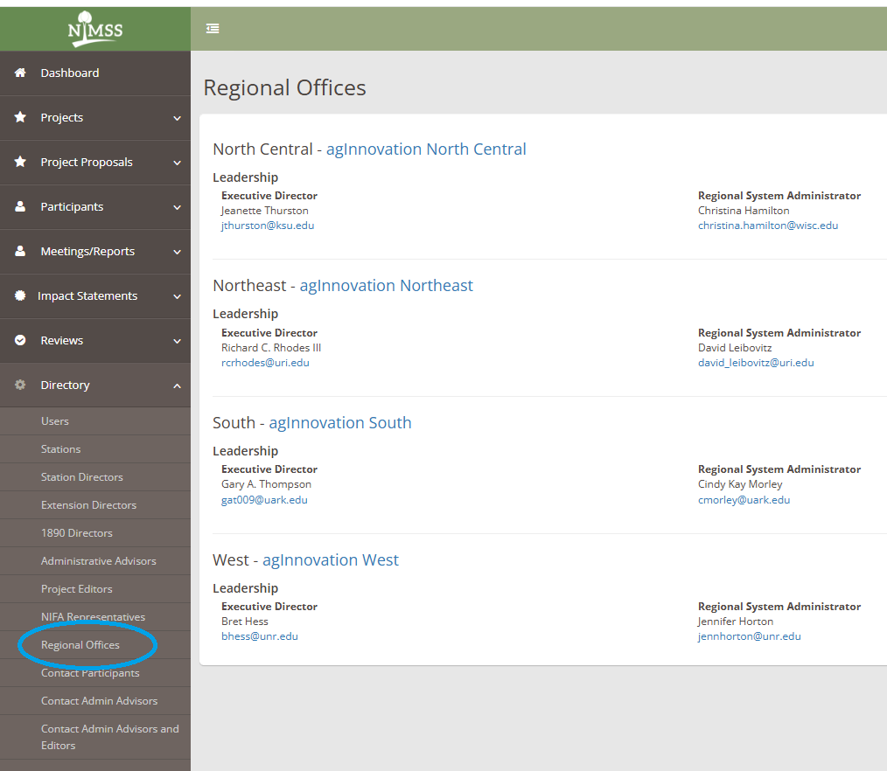

For additional information, refer to the NIMSS User Manual by navigating to Directory > NIMSS User Manual
